DB Lab 10
Laiba Fatima 22k-5195
1.
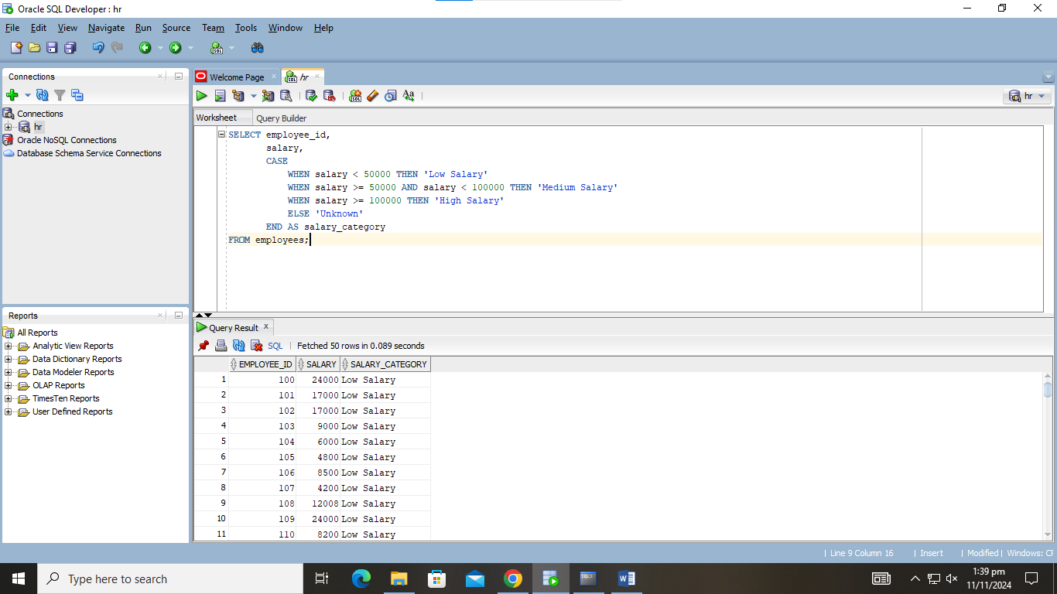
2
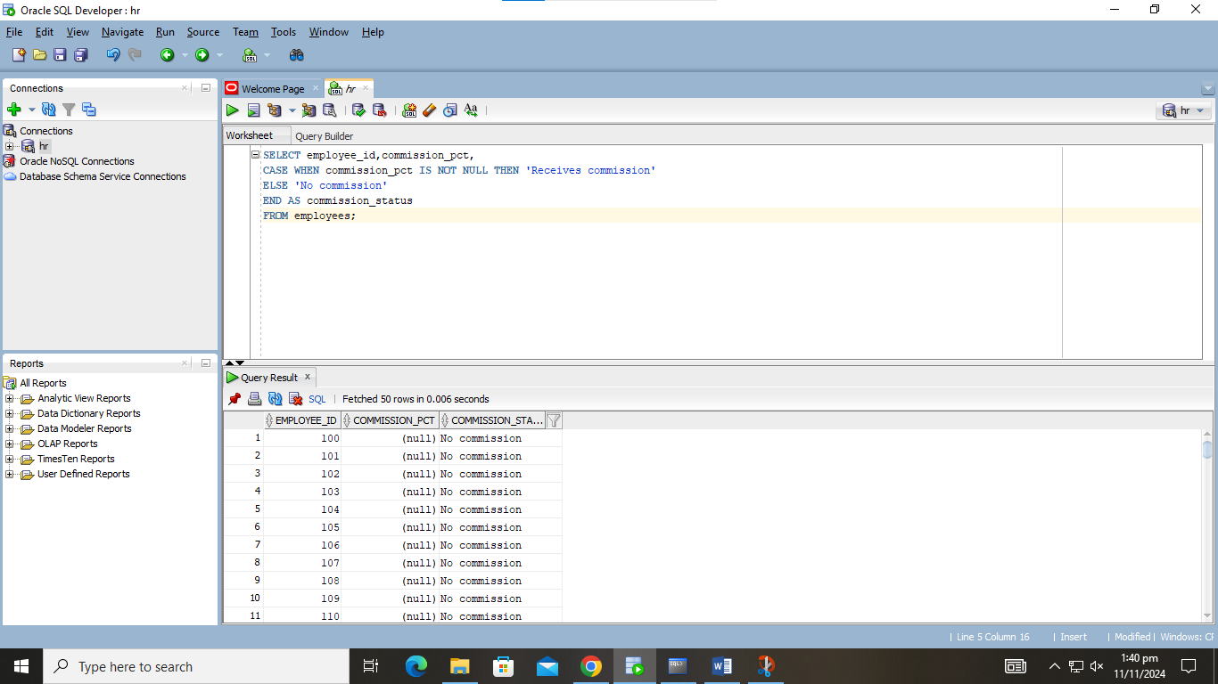

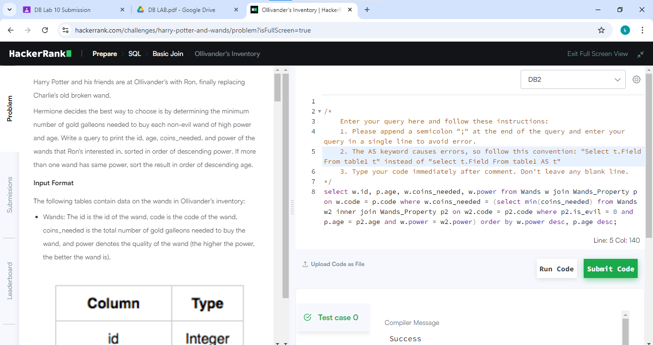

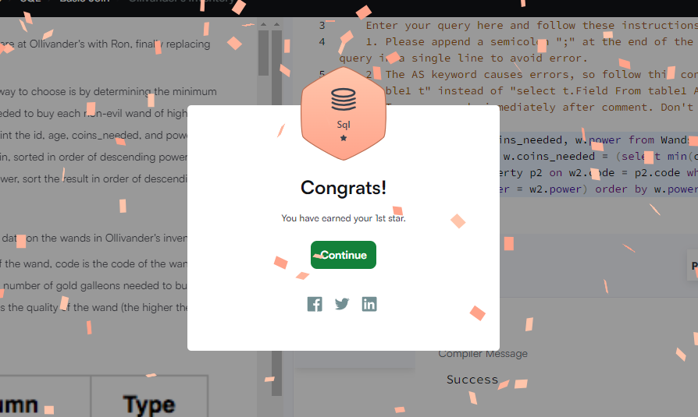

I’d like to thank my parents for this award! And Hafsah for providing me with jellies. <3

